
Mindful Humanitarian
Travel Handbook

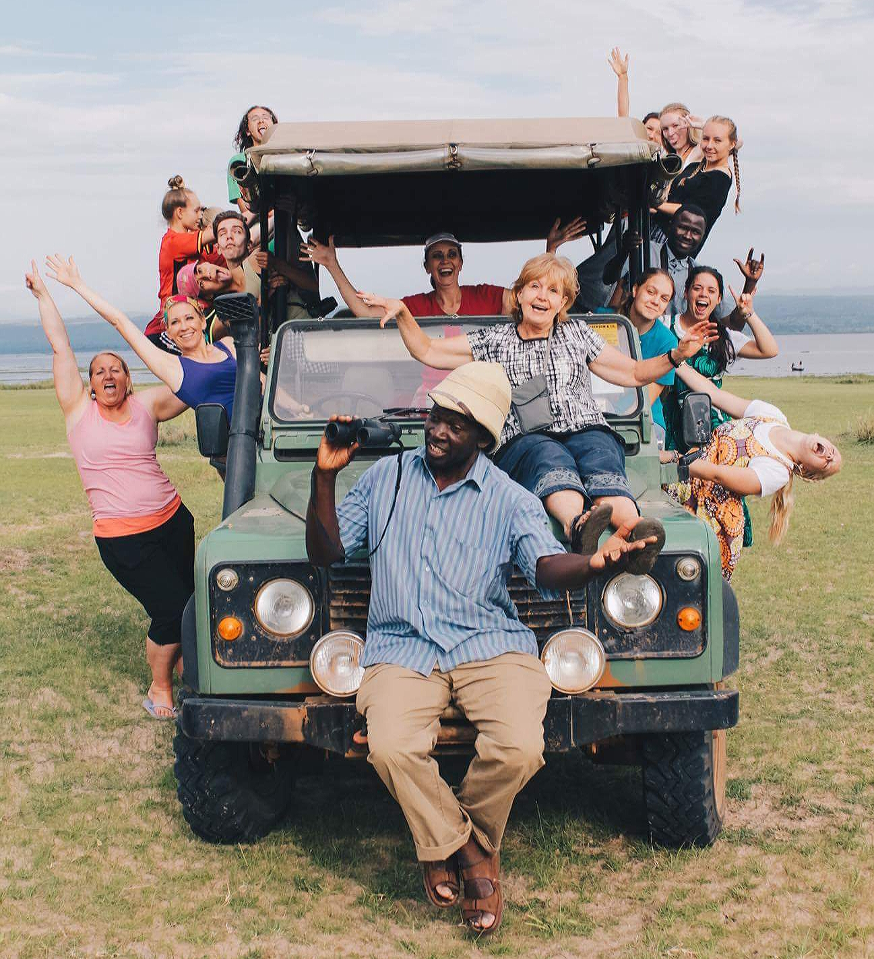

What is a Mindful Humanitarian?
In 2016 Noah Rasheta (Secular Buddhism) and Suzy Benson Gillies (African Promise Expeditions) met at a workshop where Noah was teaching a class on Mindfulness. After learning more about Noah, Suzy approached him with a crazy idea! What if Noah came to Africa with Suzy on one of her humanitarian trips and combined her already successful expedition with a mindfulness component. Thankfully, Noah didn’t hesitate, instead he jumped at the opportunity. In early 2017 Noah and Suzy successfully led a group of 16 mindful friends to Uganda. They called the expedition, “Mindful Humanitarian”. A Mindful Humanitarian trip is a combination of humanitarian work, cultural learning, mindfulness training and adventure!

What is African Promise Expeditions and
Who is Suzy?
APE is a successful organization led by Suzy Benson Gillies. Suzy has led numerous expeditions to Uganda and is thrilled to be partnering with Noah Rasheta! In addition to running African Promise Expeditions, Suzy also founded and is the Executive Director of African Promise Foundation, a 501c3 charity that benefits women and children in Uganda. The minute you decide to travel with APE Suzy will be by your side taking care of all the details. With over a dozen expeditions under her belt, Suzy has become a respected and experienced expedition leader. Suzy is also a certified Life Coach and with a focus on helping people connect with their authentic self through individual coaching, leadership training and executive development. In her spare time she enjoys traveling, dancing and anything outdoors.
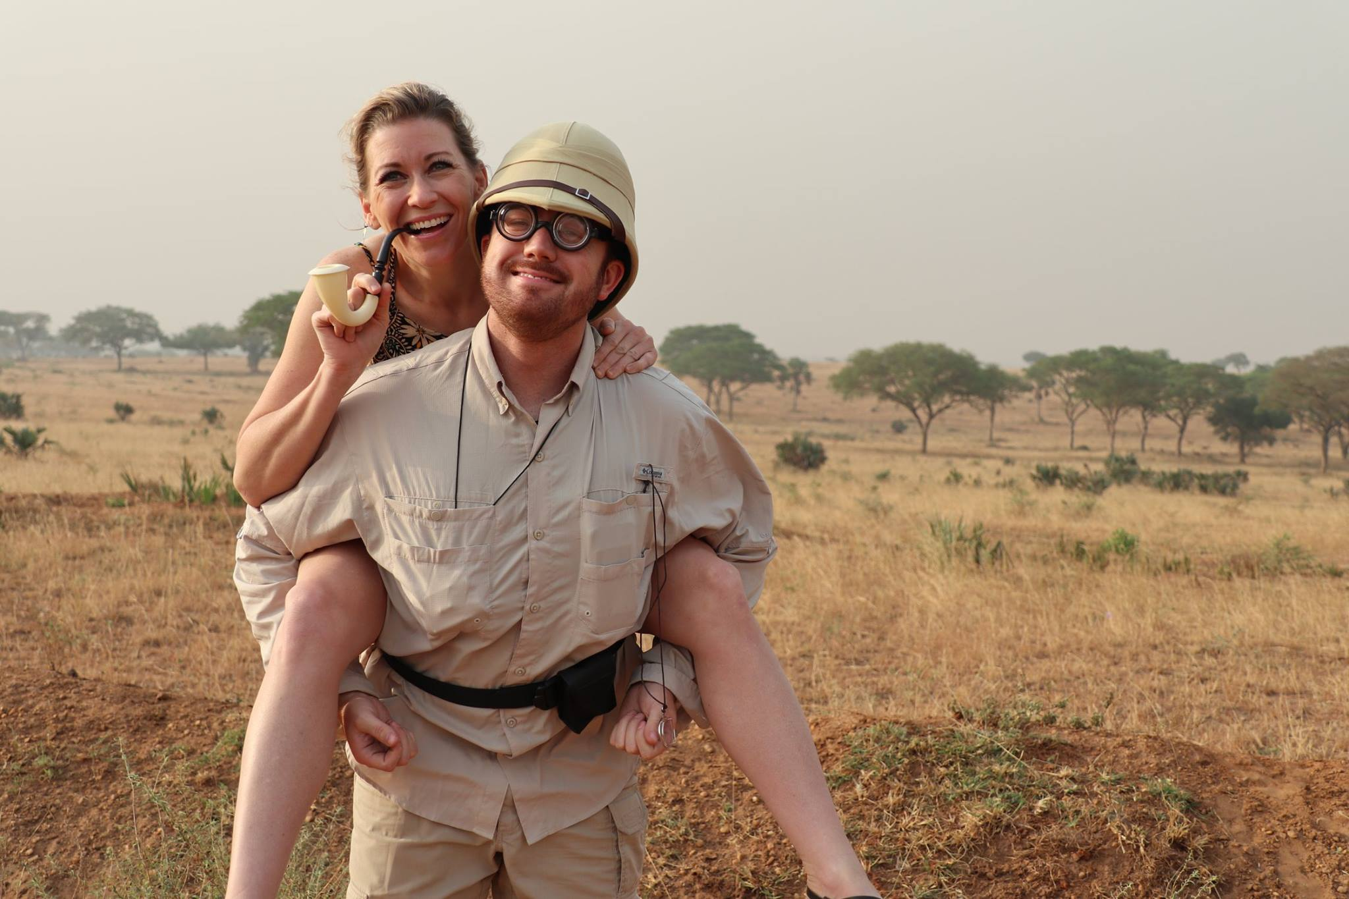

Meet Noah NoahRasheta
Noah Rasheta is the Executive Director of the Foundation for Mindful Living and host of the Secular Buddhism podcast. He teaches mindfulness and Buddhist philosophy online and in workshops all around the world. He continually strives to work with others to make the world a better place as he studies, embodies and teaches the fundamentals of Buddhist philosophy - integrating Buddhist teachings + modern science + humanism + humor. He lives in Kamas, Utah with his wife and 3 kids.
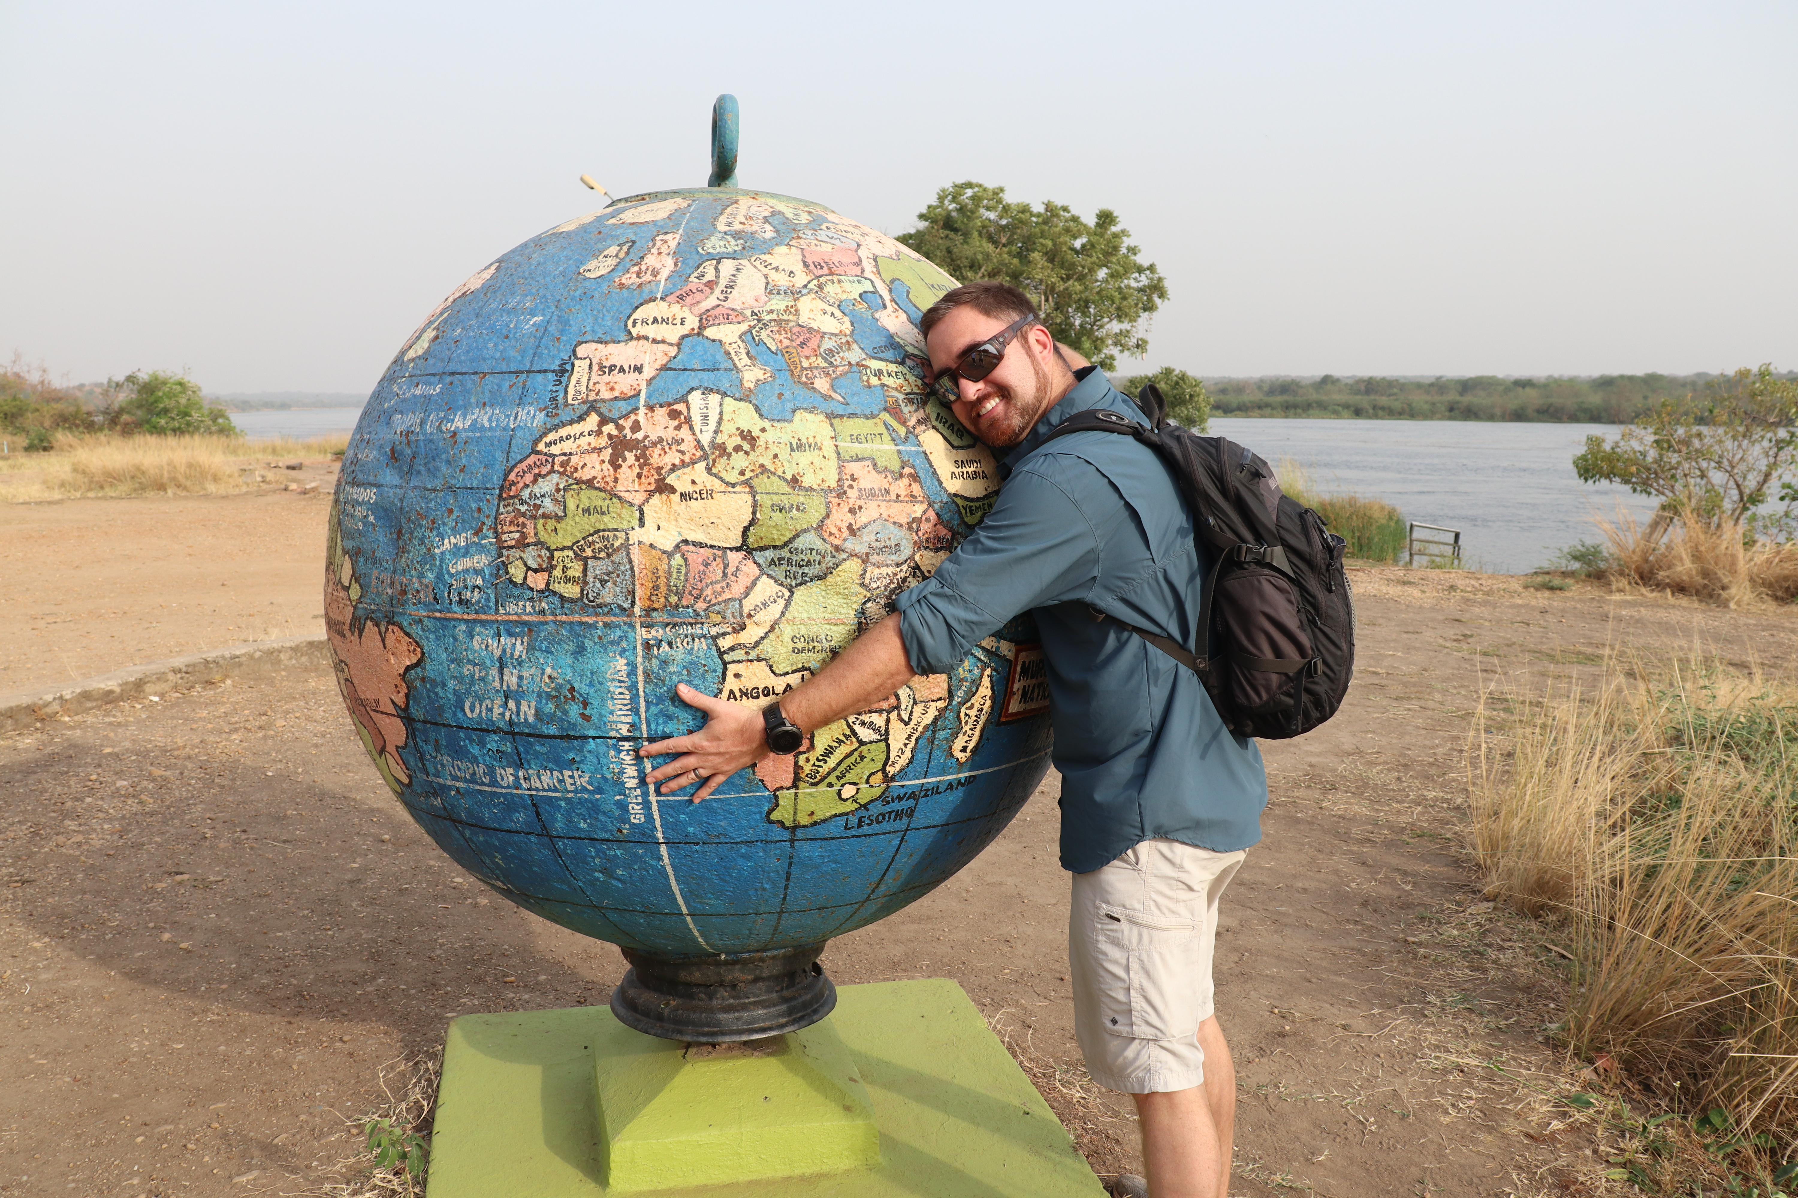

What is the mission of APE
Our overall ambition is for life transformation for our volunteers and the people we serve. Our focus is on building lasting connections within cross-cultural communities. We provide opportunities for Americans to utilize their gifts in partnering with Africans to meet their specific needs

What is included in the cost of the trip?

This trip is meant to be all inclusive, however, there are a few things that are not included. You will need to bring $50 for your visa which can be purchased at the airport. Also, any food you choose to purchase during layovers at the airport is not provided by APE. Travel insurance can be purchased and the minimum requirement is emergency medical evacuation which costs about $30. This is purchased on your own through a company independent of APE, however there are suggestions later in this manual for reputable companies. You can purchase higher levels of insurance if you want trip cancellation. Sodas and extra drinks (on safari) will be purchased by the participant. Plenty of water and juices are available at all times and are included.

What an APE/Mindful Humanitarian Trip IS:

A volunteer expedition is an opportunity for you to have a cultural exchange with some of the most beautiful people in the world. A Mindful Humanitarian Expedition is a transformational experience from the inside out. Africa has a way of cracking your heart wide open and often brings out your best self through serving and connecting with others! You will have opportunities for cultural experiences that might include home visits, spending time with students in local school and visiting a craft market.

What an APE/Mindful Humanitarian Trip IS NOT:
+ A vacation
+ A quick fix, the solution to poverty
+ An opportunity to "save" Africans

What Do We Do on a Trip?

A typical trip lasts 10-11 days. Most of your time will be spent as guests at the African Hospitality Institute. The last two days of your trip you will travel to Murchison Falls National Park where you will experience wildlife up close! A Mindful Humanitarian expedition has several components built into the itinerary. Humanitarian projects, relationship building, Mindfulness “workshops”, and adventure. Your humanitarian projects may include mudding a building and visiting homebound seniors. We will provide cultural experiences including learning to cook local foods, attending a church service and singing and dancing with locals. Our mindfulness classes include daily teachings and interactive discussions with Noah as well as morning meditation. At times Yoga may be offered. The adventure part of the trip comes in the form of a Safari and a Nile River Boat Cruise. Participants will stay at Bwana Tembo (Elephant in Swahili) with picturesque views that overlook the Nile River. A second option of Red Chilli Hideaway might be offered. At Red Chilli you will make friends with the resident warthog family! Travel by boat to see Murchison Falls in all its power and glory! You will see hippos, elephants, giraffes just to name a few and if you are lucky you will see a lion! Birding is spectacular, especially on the boat cruise. It is our belief that we come as learners and not as “Saviors”. It is our hope and desire that all participants form lasting bonds with the locals and other participants.

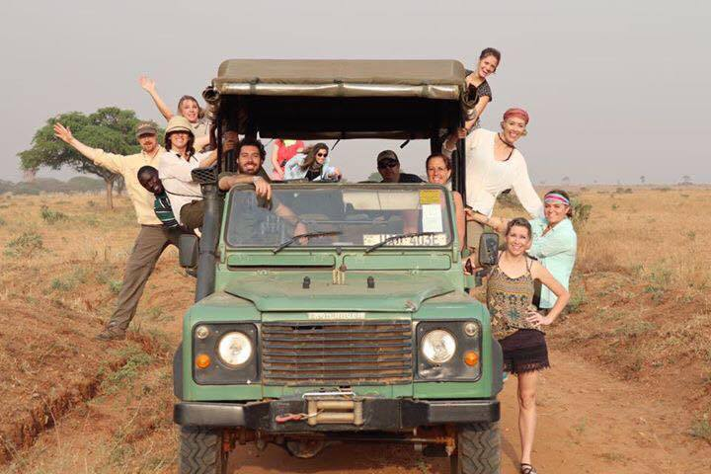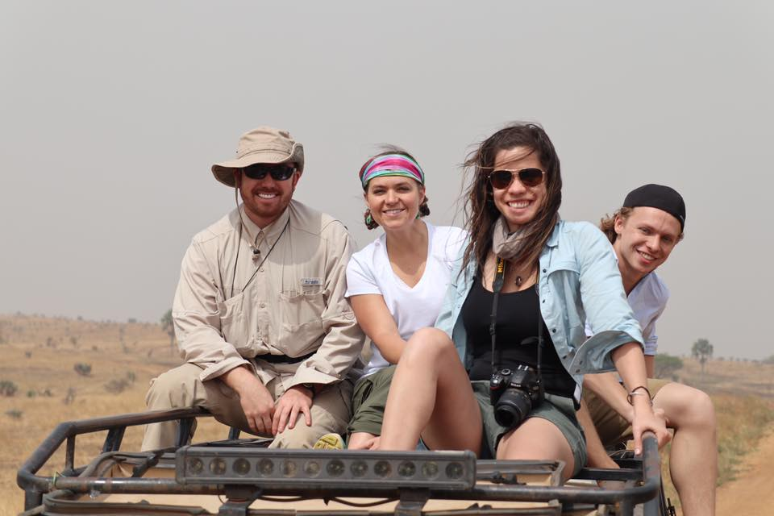

Where do we stay?
During your expedition, you will stay at the African Hospitality Institute and at Bwana Tembo Safari Camp or Red Chilli Hideaawy. The food served at AHI is considered some of the best in the country. You will have the comforts of home while you have a true African experience!

AFRICAN HOSPITALITY INSTITUTE’S MISSION:
AHI prepares vulnerable, unemployed young adults in Uganda to lead significant and productive lives.
We accomplish this through a two-year journey with an intentional mentoring community, character development and vocational training. AHI’s staff are made up of various young people who are learning skills in the hospitality industry. The students get to “practice” their skills on visitors under the guidance of Maggie Josiah, a fearless American woman who has made it her life mission to teach young people skills in the hospitality industry. In addition, they are taught life skills that will assist them in bettering their lives and future.

CORE VALUES:
COMMUNITY that fosters trust, collaboration, team work & health relationships SUSTAINABLE PLANNING for the environment and income to support AHI VOCATIONAL AND LIFE SKILLS TRAINING for young adults CHARACTER EDUCATION in values and worldview

VOCATIONAL TRAINING AND CORE VALUES:
AHI was created in 2002 to provide vocational training to chronically poor and vulnerable youth; preparing them for employment in the growing tourism and hospitality industries in East Africa. Students are admitted without regard to race, gender, or religion. Tuition and salaries are sponsored by the generous donations of individuals and organizations.

Visitors are warmly welcomed at AHI. Short-term mission groups and individuals stay at the AHI guesthouse while traveling or volunteering their services to the community.

Students gain hands on-training in an employable trade in the dining room, guestrooms, and landscaping the beautiful grounds at AHI. They learn teamwork and valuable job skills while they help provide comfortable lodging experience, quality meals, and gracious service.

AHI is attracting Hoteliers and Chefs from the USA, Holland, Italy, and Kampala to help training and recruit AHI graduates. Your generous support will help young men and women who are hardworking and highly motivated to break free from unemployment and poverty.

MAGGIE’S VISION:
Maggie was self-employed in the hospitality industry for 25 years in Kirkland, Washington, USA. She first visited the Cornerstone Ranch in 2002 as a volunteer with African Children’s Mission. She moved to the bush of Nakasongola in East Uganda full time in 2006 to build and manage the Guesthouse and vocation program.

“My dream is to see AHI continue to grow into an intentional community where daily expressions of joy, hard work, and empowerment will provide a sacred space that nourished, challenges, and transforms both the guest and host; and perhaps even the larger community. We invite guests to participate with us.”

-Maggie Josiah Founder, African Hospitality Industry

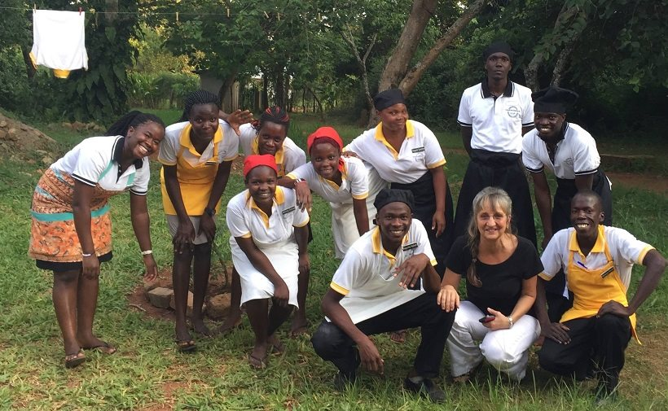
Maggie and AHI Staff

Country History

Uganda is known as the “Pearl of Africa,” as deemed by Winston Churchill during his African explorations. It is a landlocked country, bordering Kenya, Tanzania, D.R. Congo, Rwanda, and Sudan. Lake Victoria and Lake Albert also line its borders. The country is approximately the same size as Oregon. It is one of the only countries that lies on the equator, with mountain ranges on the eastern and western borders. The natural landscape of lush green hillsides and red sand is almost as beautiful as the people, who are some of the friendliest people in Africa.

The history of Uganda dates back to the fourth century B.C. when Bantus inhabited the Lake Victoria area to hunt and farm. Over the centuries, other tribal clans settled in the area, and by the 1800s, the people had established themselves as the people of Buganda and were ruled by a king. By 1860, the British began influencing the area through colonization, and they brought their own political ruling system. Christian missionaries also brought with them new ideas. By 1888, the British East Africa Company claimed the territory; however, they had little power until 1894 when the British founded Uganda as a protectorate. The British signed treaties with several tribal groups in Uganda, but they gave most power to the Baganda, which caused later conflict among the tribes. The British influenced much of the economy in the early 1900s by establishing infrastructure to transport coffee, cotton, and other cash crops.

The Ugandans supported the British during World War II; however, after the war, the Bagandans rioted in opposition to British economic policy. By 1961, England granted Ugandans the right to self-rule, and in 1962 a prime minister was put into power—Milton Obote of the Uganda People’s Congress ruled peacefully alongside King Frederick Walugembe Mutesa II. By 1966, Obote no longer wanted to share the power of Uganda, so he ordered General Idi Amin Dada to overthrow the king, and in 1967, Obote abolished kingdoms and established a new constitution in which presidents ruled. In 1971, Idi Amin overthrew Obote and designated himself as ruler of Uganda. He ruled for eight years in absolute terror, killing anyone who might oppose him, exiling Indians, and invading Tanzania, but by 1979 the Uganda National Liberation Army rebelled and sent Amin fleeing captivity. Once Amin was overthrown, Obote regained power, but soon faced opposition from the National Resistance Army (NRA), led by Yoweri Museveni, which drove Obote out of power. By 1986, the NRA had gained complete power and began setting new political reforms. In 1995, a new constitution allowed for nonparty presidential elections, and Museveni was elected president in 1996. He has ruled since then.

Full Country Name: Republic of Uganda
Capital: Kampala
President: Yoweri Museveni
Area: 237,000 sq miles (91,506 sq km)
Population: 24,600,000
Religion: Roman Catholic (33%), Protestant (33%), indigenous beliefs (18%), Muslim (16%)
Government Type: Republic
Language: English, Acholi, Luganda and other tribal languages to a lesser extent. While many uneducated (especially women) don't know English, it is relatively easy to find someone who can translate.
Education: Approx. 8500 primary schools and 1000 secondary & technical training schools. Main higher education institutions are Makerere University and Uganda Technical College in Kampala
Literacy: approx. 50%
Religion: 67% Christian, 33% other religions such as animism, Islam, Sikhism, Hinduism. There are many Catholics, Born Again Christians, and Muslims. All of these groups are open to APF 's work and provide a great infrastructure to work with. The people are used to Christian missionaries, so it is important to stress that APE is there to do development work, not to promote a particular faith.

Making international phone calls:
Using What’s App and Facebook Messenger will work best when you have Wi-Fi. Otherwise, Suzy will have a phone that you can use in emergency situations or if you need to touch base with your family. They can also call this number at anytime. There will be no Wi-Fi at African Hospitality Institute, but there MIGHT be on Safari. It’s best to get an international phone plan while you are traveling if that is important to you.
Climate: Tropical and lush with temperatures averaging at 80 degrees in the day and 50-60 degrees at night. The landscape is very green with red dirt. The scenery is picturesque, and the sunsets will take your breath away.
Currency: Ugandan shilling (approx. 3500 shillings = $1US)

Popular Local Foods In Uganda Include:
Staples
Chipatti: a thick fried flour tortilla, sort of like Indian flatbread
Rolex: a chipatti with fried egg, tomato, and cabbage all rolled up
Samosas: deep fried dough pockets filled with meat & onions or beans
Matoke: plantain that is steamed and mashed, tastes much like potato but sweeter. It is the staple in Uganda and is served with almost every meal, and the locals’ favorite food
Cassava: another type of root that is boiled and mashed like a potato. Cassava, matoke, sweet potatoes, or Irish potatoes are typically served for dinner.
Posho: a grainy flour substance of ground maize that is mixed with water and cooked to serve as a porridge or a side dish with beans or sauce on top.
Rice and Beans: G-nut: stands for “ground nut,” and is a peanut sauce that is made to put on matoke or posho

Vegetables
Pumpkin Squash:
Cabbage: a good source to get your greens
Eggplant:.
Avacado: absolutely amazing.

Fruits
Mangos: Sometimes it’s difficult to find a ripe mango, but when you do, you’ll love it. They’re in season during May and June, not in July & August, so get your fill while you can.
Pineapple: Amazingly sweet, and always ripe and plentiful. Enjoy it lots!
Papaya: Difficult to tell when it’s ripe, so have someone at the market help you pick one, but they’re so good when ripe.
Jackfruit: A really sweet, juicy fruit with a pit in the middle. A must try!
Passion fruit: Good stuff!
Bananas: Plentiful and good for getting rid of diarrhea.
Apples & oranges: Less common and surprisingly more expensive than other fruits.

Meats
Beef: Usually served cubed. Can be tough and chewy.
Goat: Much like the beef.
Chicken: Less common because it’s a delicacy. Usually not much meat on the chicken, and also pretty chewy
Fish: If you like fish, you’re in luck. There’s a lot to choose from in Uganda. The most popular are Tilapia and Nile Perch, big white fish served fried or boiled, never de-boned or beheaded.

What do we eat?
There will be times that we have traditional foods, but for the most part we will eat foods that you are familiar with. African Hospitality Institute, where you will be staying for the majority of the time is known to have the best chefs in Uganda. Food will be fresh, plentiful and organic. You will not be hungry and will probably walk away with the feeling that you are “stuffed”!
During safari, you will also be full and impressed with the high quality of food! Sodas will be available on safari and are cold and refreshing!

Beverages
Water: During your stay at the African Hospitality Institute the water is perfectly safe to drink. It is boiled and double filtered. You will have water in your room and can fill your water bottle daily. In addition, any hotel we stay at should have filtered water, otherwise bottled water is the only water you should drink. Only used filtered or bottled water to brush you teeth.
Soda: Soda is available in Uganda (Not at African Hospitality Institute)
Coke, Pepsi, Fanta
Mirinda: Fruity flavors like grape and strawberry
Krest: Bitter lemon drink
Juices: Plenty of fruit juices are available. The most popular is passion fruit juice, and it’s tasty. You can also get mango juice, orange juice, apple juice, etc. At AHI fresh fruit juice is available daily.

Center for Disease Control – Traveler’s Health
Information Taken from the Center for Disease Control website:
http://wwwn.cdc.gov/travel/destinationUganda.aspx
*ALTHOUGH INFORMATION PROVIDED IN THIS HANDBOOK IS HELPFUL, YOU SHOULD CONSULT A TRAVEL CLINIC TO GET THE MOST UP TO DATE INFORMATION. APE CANNOT ADVISE YOU ON SHOTS AN MEDICATION. THE INFORMATION BELOW IS A GUIDELINE FOUND ON THE CDC WEBSITE.
Preparing for Your Trip to Uganda
Before visiting Uganda, you may need to get the following vaccinations and medications for vaccine-preventable diseases and other diseases you might be at risk for at your destination: (Note: Your doctor or health-care provider will determine what you will need, depending on factors such as your health and immunization history, areas of the country you will be visiting, and planned activities.)
To have the most benefit, see a health-care provider at least 3 TO 4 months before your trip to allow time for your vaccines to take effect and to start taking medicine to prevent malaria, if you need it. Even if you have less than 4 weeks before you leave, you should still see a health-care provider for needed vaccines, anti-malaria drugs and other medications and information about how to protect yourself from illness and injury while traveling.
CDC recommends that you see a health-care provider who specializes in Travel Medicine. Find a travel medicine clinic near you. If you have a medical condition, you should also share your travel plans with any doctors you are currently seeing for other medical reasons. If your travel plans will take you to more than one country during a single trip, be sure to let your health-care provider know so that you can receive the appropriate vaccinations and information for all of your destinations. Long-term travelers, such as those who plan to work or study abroad, may also need additional vaccinations as required by their employer or school.
Routine vaccines, as they are often called, such as for influenza, chickenpox (or varicella), polio, measles/mumps/rubella (MMR), and diphtheria/pertussis/tetanus (DPT) are given at all stages of life; see the childhood and adolescent immunization schedule and routine adult immunization schedule. Routine vaccines are recommended even if you do not travel. Although childhood diseases, such as measles, rarely occur in the United States, they are still common in many parts of the world. A traveler who is not vaccinated would be at risk for infection.

Vaccine-Preventable Diseases

Vaccine recommendations are based on the best available risk information. Please note that the level of risk for vaccine-preventable diseases can change at any time.
Vaccination or Disease | Recommendations or Requirements for Vaccine-Preventable Diseases
Routine | Recommended if you are not up-to-date with routine shots such as, measles/mumps/rubella (MMR) vaccine, diphtheria/pertussis/tetanus (DPT) vaccine, poliovirus vaccine, etc.
Yellow Fever | CDC yellow fever vaccination recommendation for travelers to Uganda: For all travelers >9 months of age. Uganda requires travelers arriving from countries where yellow fever is present to present proof of yellow fever vaccination. Vaccination should be given 10 days before travel and at 10 year intervals if there is on-going risk. Find an authorized U.S. yellow fever vaccination clinic.
Hepatitis A or immune globulin (IG) | Recommended for all unvaccinated people traveling to or working in countries with an intermediate or high level of hepatitis A virus infection (see map) where exposure might occur through food or water. Cases of travel-related hepatitis A can also occur in travelers to developing countries with "standard" tourist itineraries, accommodations, and food consumption behaviors.
Hepatitis B | Recommended for all unvaccinated persons traveling to or working in countries with intermediate to high levels of endemic HBV transmission (see map), especially those who might be exposed to blood or body fluids, have sexual contact with the local population, or be exposed through medical treatment (e.g., for an accident).
Typhoid | Recommended for all unvaccinated people traveling to or working in East Africa, especially if visiting smaller cities, villages, or rural areas and staying with friends or relatives where exposure might occur through food or water.
Meningococcal (meningitis) | Recommended if you plan to visit countries that experience epidemics of meningococcal disease during December through June (see map).
Rabies | Recommended for travelers spending a lot of time outdoors, especially in rural areas, involved in activities such as bicycling, camping, or hiking. Also recommended for travelers with significant occupational risks (such as veterinarians), for long-term travelers and expatriates living in areas with a significant risk of exposure, and for travelers involved in any activities that might bring them into direct contact with bats, carnivores, and other mammals. Children are considered at higher risk because they tend to play with animals, may receive more severe bites, or may not report bites. Note: Rabies vaccine is temporarily in limited supply. For updates on the rabies vaccine supply, please check the Rabies News and Highlights page regularly.
Polio | Recommended for adult travelers who have received a primary series with either inactivated poliovirus vaccine (IPV) or oral polio vaccine (OPV). They should receive another dose of IPV before departure. For adults, available data do not indicate the need for more than a single lifetime booster dose with IPV.

Malaria
Drugs to Prevent Malaria (antimalarial drugs) usually Doxycycline or Malarone. Please consult a travel clinic doctor Note: Chloroquine is NOT an effective antimalarial drug in Uganda and should not be taken to prevent malaria in this region.

Prevent Insect Bites
Many diseases, like malaria and dengue, are spread through insect bites. One of the best protections is to prevent insect bites by:
- Using insect repellent (bug spray) with 30%-50% DEET. Picaridin, available in 7% and 15% concentrations, needs more frequent application. There is less information available on how effective picaridin is at protecting against all of the types of mosquitoes that transmit malaria.
- Wearing long-sleeved shirts, long pants, and a hat outdoors.
- Remaining indoors in a screened or air-conditioned area during the peak biting period for malaria (dusk and dawn).
- Sleeping in beds covered by nets treated with permethrin, if not sleeping in an air-conditioned or well-screened room.
- Spraying rooms with products effective against flying insects, such as those containing pyrethroid.

Prevent Animal Bites and Scratches Direct contact with animals can spread diseases like rabies or cause serious injury or illness. It is important to prevent animal bites and scratches.
- Be sure you are up to date with tetanus vaccination.
- Do not touch or feed any animals, including dogs and cats. Even animals that look like healthy pets can have rabies or other diseases.
- Help children stay safe by supervising them carefully around all animals.
- If you are bitten or scratched, wash the wound well with soap and water and go to a doctor right away.
- After your trip, be sure to tell your doctor or state health department if you were bitten or scratched during travel.
For more information about rabies and travel, see the Rabies chapter of the Yellow Book or CDC's Rabies homepage. For more information about how to protect yourself from other risks related to animals, see Animal-Associated Hazards.

Be Careful about Food and Water
Diseases from food and water are the leading cause of illness in travelers. Follow these tips for safe eating and drinking:
- Wash your hands often with soap and water, especially before eating. If soap and water are not available, use an alcohol-based hand gel (with at least 60% alcohol).
- Drink only bottled or boiled water, or carbonated (bubbly) drinks in cans or bottles. Avoid tap water, fountain drinks, and ice cubes. Drinks will be provided by APF.
- Do not eat food purchased from street vendors.
- Make sure food is fully cooked. If it hasn’t been boiled or peeled, don’t eat it!
- Avoid dairy products, unless you know they have been pasteurized.
Diseases from food and water often cause vomiting and diarrhea. Make sure to bring diarrhea medicine with you so that you can treat mild cases yourself.

Avoid Injuries
Car crashes are a leading cause of injury among travelers. Protect yourself from these injuries by
- Wearing your seatbelt if provided (often not available)
- Following local traffic laws.

Other Health Tips
- To prevent fungal and parasitic infections, keep feet clean and dry, and do not go barefoot, especially on beaches where animals may have defecated.
Important Note: This document is not a complete medical guide for travelers to this region. Consult with your doctor for specific information related to your needs and your medical history;

Consular Information Sheet -Uganda
U.S. Department of State Bureau of Consular Affairs
http://travel.state.gov/travel/cis_pa_tw/cis/cis_1051.html
COUNTRY DESCRIPTION: Uganda is a landlocked, developing country in central eastern Africa. Infrastructure is adequate in Kampala, the capital, but is limited in other areas. Read the Department of State Background Notes on Uganda for additional information.
ENTRY/EXIT REQUIREMENTS: A passport valid for SIX months beyond the date of entry, visa and evidence of yellow fever vaccination are required.
Visa: Can be purchased at the airport. The cost is $50. Please have cash on hand. Denominations or $50 and $100 only 2009 or newer. No tears or markings should be found on the bills.
SAFETY AND SECURITY: For the latest security information, Americans traveling abroad should regularly monitor the Department’s web site at http://travel.state.gov where the current Travel Warnings, Travel Alerts, and the current Worldwide Caution can be found.
Up-to-date information on safety and security can also be obtained by calling 1-888-407-4747 toll free in the U.S. and Canada, or for callers outside the U.S. and Canada, a regular toll-line at 1-202-501-4444. These numbers are available from 8:00 a.m. to 8:00 p.m. Eastern Time, Monday through Friday (except U.S. federal holidays).
The Department of State urges American citizens to take responsibility for their own personal security while traveling overseas. For general information about appropriate measures travelers can take to protect themselves in an overseas environment, see the Department of State’s pamphlet A Safe Trip Abroad.
MEDICAL FACILITIES AND HEALTH INFORMATION: Travelers should carry their own supplies of prescription drugs and preventive medicines. A list of medical providers is available at the U.S. Embassy. There are international hospitals should the need arise for medical care.
Consult your local travel clinic to obtain shots and prescriptions for Malaria. If your insurance covers your prescriptions, please try to get 2 different kinds of malaria medications as sometime people have a bad reaction to one. Malarone and Doxycycline are the two most common. Cipro is also recommended for traveler's diarrhea. DO NOT WAIT TO GET YOUR SHOTS GOING. SOME SHOTS ARE A SERIES!
MEDICAL INSURANCE: The Department of State strongly urges Americans to consult with their medical insurance company prior to traveling abroad to confirm whether their policy applies overseas and whether it will cover emergency expenses such as a medical evacuation. Please see our information on medical insurance overseas. A limited travel insurance policy shall be purchased by each player.
TRAVEL INSURANCE: This is required and can be purchased on your own. You are only required to get emergency medical and evacuation. It is usually between $30-$100. It is up to you to purchase a higher coverage if you want more protection. Some companies allow you to purchase a policy that will reimburse you for airfare and your trip fee (what you paid to APE) for a higher cost. Faithventures.com or hthtravelinsurance.com are good companies to use.
SPECIAL CIRCUMSTANCES: Please note that U.S. currency notes less than $50 denominations are not accepted to exchange. Each traveler must have $100 or $50 currency notes. In addition, travelers cannot exchange or use U.S. currency printed earlier than the year 2009. Please don’t rely on ATM’s. Carry cash and use a debit card as a back up plan. Althought there are ATM’s we will not be around one.
Photography in tourist locations is permitted. However, taking pictures of military/police installations or personnel is prohibited as well as bridges. Military and police officers have detained tourists for taking photographs of Entebbe Airport and of the area around Owen Falls Dam, near Jinja, although the prohibition on taking photographs is not publicly displayed on signs.
CRIMINAL PENALTIES: While in a foreign country, a U.S. citizen is subject to that country's laws and regulations, which sometimes differ significantly from those in the United States and may not afford the protections available to the individual under U.S. law. Penalties for breaking the law can be more severe than in the United States for similar offenses. Persons violating Ugandan laws, even unknowingly, may be expelled, arrested or imprisoned. Penalties for possession, use, or trafficking in illegal drugs in Uganda are severe, and convicted offenders can expect long jail sentences and heavy fines.
REGISTRATION / EMBASSY LOCATION: Americans living or traveling in Uganda are encouraged to register with the U.S. Embassy through the State Department’s travel registration web site so that they can obtain updated information on travel and security within Uganda. Americans without Internet access may register directly with the nearest U.S. embassy or consulate. By registering, American citizens make it easier for the Embassy or Consulate to contact them in case of emergency. The U.S. Embassy is located at 1577 Ggaba Road, Kampala; telephone 256-414-259-791 or 256 414 306 001; fax 256-414-258-451; e-mail: Kampalauscitizen@state.gov. The U.S. Embassy web site is http://kampala.usembassy.gov. SUZY WILL REGISTER YOU WITH THE STATE DEPARTMENT. YOU DO NOT NEED TO DO THIS.

APE's International SECURITY STATEMENT
African Promise Expeditions is dedicated to offering a wide variety of volunteer opportunities to people of all ages seeking to change their lives while creating positive change in the world. We know that we are as safe as our least informed and vigilant volunteer.

APE has recognized the importance of establishing policies and procedures in the effort to protect the safety and well-being of APE participants, while acknowledging that no single plan can address all contingencies. Listed below are a few of the ways APE strives to keep our programs, before and during participation, as safe as possible.
- APE regularly and responsibly monitors safety issues in each of our program locations. A review of all programs at a local, regional, and country level is conducted in which safety, security, and overall quality are measured.
- All APE's programs are registered with the State Department and routinely receive updates.
- All participants are required to attend a health, safety, and security training session that stresses safety issues and understanding cultural differences. In this session we also provide a country specific orientation in which safety precautions are outlined.
- Unless there is significant risk, APE will still travel with a security warning. Security warnings are typically for specific locations and are not places we will visit. It is up to the participant to get travel insurance so if something arises and a participant wishes to drop out of the trip, they can get their money back through their insurance company.

APE strives to keep volunteers informed of conditions and decisions related to travel safety and well-being. However, in these changing times, it is necessary that each volunteer take responsibility for his/her own safety by staying informed and conducting themselves accordingly. We provide tools and resources about a variety of such issues, including information from the U.S. State Department about volunteers having a "safe trip abroad", the consular information sheet for each country, and security briefings distributed by the U.S. State Department local Regional Service officers.

FAQ:

If you didn't find the answer you are looking for below, here is a quick summary of often asked questions.

Can I call home on my cell phone? At AHI there is no Wi-Fi you will have access to Wi-Fi for short amounts of time during your days on safari. Suzy will have a phone and the number will be provided to your loved ones who might need to get in touch with you. You may use this phone while at AHI to call home if necessary. Suzy will have access to the internet via AHI and will frequently give updates via a FB page that families can follow and monitor our activities.
Where do I find out what shots and medicines I need? Look on the internet for a location in your area that provides Travel Medicine. They will have current information on shots and medicines and can write prescriptions for you.
How do we travel in country? We travel via a private bus and bicycle in the village. There is a motorbike with a carriage at AHI for those that can’t bike.
I like to have personal space, will I have any on this trip? You will most likely have a roommate but the accommodations are very comfortable and spacious! There will be plenty of time to get lost in a hammock and breathe, meditate, journal etc. In some cases you may have your own room but there is no guarantee.
I'm not a very easygoing or flexible person, should I go on this trip? While we would love to have anyone volunteer, ALL volunteers must commit to being flexible and easy to travel with. APE participants can find themselves in stressful situations that demand cooperation and flexibility. We are looking for flexible people that can go with the flow.
What are the sleeping accommodations like? Do we need a mosquito net? AHI provides a beautiful “lodge” where you will have clean, comfortable rooms with fresh linens and hot water. You will also have comfortable accommodations at the Safari Camp. You do not need a mosquito net.
Is it safe? The most dangerous thing you will find in Uganda is the driving. APE follows strictly the advice of the U.S Department of State and will avoid the "tourist" spots, large crowds and stadiums. The rural areas we travel too have never been places the State Dept. has recommended avoiding.
What kind of food will we eat? The food in Uganda is delicious! AHI provides Western style meals as well as staple Uganda foods. You will not be hungry, in fact you will probably gain a few pounds. Everything is cooked from scratch with organic ingredients! The Safari Camp is run by Italians and all food is made from scratch and we are served 4 course meals!
What IS NOT covered in my participation fee? Airport food, Visa ($50), Travel Insurance, Shots, Passport, Souvenirs, sodas and snacks on safari
Can I do Laundry? At AHI laundry service is provided.
How Much Money Should I bring? You should not need very much cash once in country. The amount of money you bring depends on how much you want to spend on crafts and souvenirs. Most people feel that $100 is plenty for souvenirs. Keep in mind, ATM's are very common now and you should be able to get cash if there is an emergency. You should carry at least $100 and bring one debit card.
What should I wear? The region AHI is located in is a very conservative area. Women are expected to wear skirts that are knee length or longer or dresses. No sleevless or tanks in the village. At AHI women can wear capri pants or long pants and sleeveless shirts. Men will need to wear long sleeve light weight pants in the village but can wear tank tops and shorts at the ranch. Respecting the cultural norms is critical in order to maintain relationships and be welcome in the future. On safari, you can feel free to wear comfortable shorts and tanks.
Is this a religious trip? APE is not a religious organization and is not affiliated with any religion. We expect all of our participants to respect everyone, regardless of their religious beliefs and not proselyte or push their convictions onto others within our own group or in the Ugandan communities we partner with. AHI is set in a Christian community. We respect their beliefs and values but you are not required to hold the same beliefs. Our relationship with AHI is one of respect. Uganda in general has a very conservative Christian culture. APE participants can view this as part of the cultural experience, but in no way do we push, expect or promote any religion. You might have an opportunity to participate in a Sunday service or sing hymns but this is completely optional.
What happens if I cannot fly in on the same flight as the group? Suzy will work with you as you book your flight. If you can’t match up with the group, it is best to fly in early. Suzy can help you arrange for a nearby comfortable hotel to pick you up so that you can rest before the group arrives. This will add a minimal cost and will be paid by the participant.

APE Packing Information and Packing List

Luggage Information: Note, this info. can change depending on airlines: It is up to you to check with your airline. Generally liquids need to be in a quart size bag and 3 oz. or less

A neck pouch or money belt should be worn under clothing for cash/credit or debit card & passport--which you need at all check in points with the boarding pass. NO EXCEPTIONS!
What goes in the neckpouch?
- Yellow Fever Card
- Passport
- Credit Card
- Money ($50 cash for Visa, $100 or more for spending)

Carry on Bag: The following items must be taken in carry on bag! NO EXCEPTIONS!
In the carry on bag, you must pack all of the things that you cannot live without if your luggage is lost. If your bag doesn’t show up, this is all you will have.
- Change of Clothes
- 3 Pair Underwear
- All Prescription Medicine
- One copy of Passport (Page with your picture)
- Alternate ID
- All hygiene items that you cannot survive without ie. Contact solution, toothpaste, toothbrush, bug spray 3 oz or less bigger liquids can go in checked bag
- Glasses (If you wear them) I would include sunglasses if that’s important to you.
- Cameras
- Whatever you sleep in
- All Team T-shirts need to be in carry on and anything else you can fit that you would want to have along if your bag is lost.
- Remember! This is Africa (TIA) there is a chance your checked bag will not arrive! We have never had this happen before, but just in case!

Clothing
- 5-6 lightweight, durable shirts (these can include your APE t-shirt)
- 1 pairs of capris/pants/jeans (lightweight are best, remember it is hot!) More for men
- 1 sweatshirt or jacket
- 3-5 skirts, mid-knee length and longer.
- Shorts for safari and shopping day only. You cannot wear shorts at AHI except in your room.
- Rain poncho if it's the rainy season (dollar store type)
- Pajamas
- 3-4 pairs of socks (if you are wearing shoes that need socks
- Underwear
- Hat, if you are sensitive to the sun
- Sunglasses

Shoes
- Teva or Chaco type sandals (good for vacation to the beach/ waterfalls, rivers, etc)
- Flip flops (for the shower) not recommended for walking around in case you step on something sharp
- Whatever kind of shoes are comfortable to you. You will want some good walking shoes. We will be riding bikes so where shoes you can bike in.

Supplies / Etc
- Journal/pens and pencils
- Backpack, fanny pack or cinch bag (for daily use)
- Head lamp flashlight (Target or Wal-Mart carry these)
- Adapter if you need to charge anything. (Plugs are the same kind as Great Britain) Electrical Plugs:  220V 50Hz
- Camera or Phone to take pictures

Personal items
- Shampoo/conditioner
- Kleenex (travel sized)
- Mini-1st aid kit (band-aids, Neosporin, alcohol wipes) Team leader will also have a big first aid kit
- If you wear glasses, try to bring an extra pair. If you wear contacts, bring a pair of glasses
- Contact Solution
- Deodorant
- Toothbrush/ toothpaste
- Medication (Tylenol, Tums, Immodium, Pepto, stool softener, etc) Team leader will also bring these items
- Prescriptions (Must be in carry on bag!)
- Make-up (if you can’t live without it)
- Bug repellent and after bite itch cream
- Black Walnut and Garlic Supplements are know to keep bugs away (optional)
- Feminine hygiene products (you can’t get tampons in Uganda)
- Sunblock & aloe
- Hand sanitizer/Hand Wipes, you will want these!
- Multi-vitamins (even if you don’t normally take them, your body will thank you)
- Pro-biotic, optional (to keep friendly bacteria healthy)
- Dramamine if needed

Miscellaneous
- Money: Your money may not have marks or tears on it. (make sure bills are $50.00 or $100.00 only and later than 2009 or your money is no good)
- Debit Card - VISA and MASTERCARD are the easiest to use, but ATM's accept Visa much more frequently (know your pin #s)
- Neck pouch-you can get these at Wal-Mart! You must have one!
- Granola bars, power bars, beef jerky, candy, trail mix or dried fruit etc, trust me, you will want snacks!
- Family photos to show or share, this is a huge hit, you may want to print out pictures of your family as the people will want to remember you!
- Postcards of your city or state to give away
- Small give away items for people who are very helpful
- Earplugs – if you have a hard time sleeping with noise
- Copy of your passport (one left at home and one in carry on)

Items not to take:
- Jewelry or expensive watches or clothing
- Expensive electronic devices
- Anything you would hate to lose
- YOU CANNOT USE HAIR DRYERS, FLAT IRONS, OR CLOTHING IRONS AT AHI. THEY OPERATE ON SOLAR AND YOUR APPLIANCE WILL HARM THEIR SYSTEM

QUICK HINTS FOR PACKING and TRAVELING

The preceding packing list is not to be regarded as all-inclusive or the perfect list of items you will want to bring to Uganda. As everyone is different, we suggest that you use this list as a guideline. You should also consult with your leader if you have any other questions.

All airlines have different guidelines for the weight and number of bags you are allowed to bring. We request that your checked bags are used for supplies and donations that APE brings along. Suitcases are a big NO. They weigh too much. APE can give you bag suggestions, but thin, lightweight duffels work best.

Other hints
- Dress conservatively, skirts for ladies, long pants for men
- Keep all medicines in their original, labeled containers
- Choose fabrics carefully. Natural fabrics may be cooler, but wrinkle more easily, dry more slowly, and are generally heavier than synthetics. Knitted fabrics are less prone to creasing.
- Deal with temperature variations by layering, not by packing heavier clothing
- Avoid green camouflage clothing
- Bring comfortable clothing and undergarments
- Tie something on your bags that you will recognize. Bright and obnoxious is best!
- Make sure all suitcases and carry-on bags have completed nametags
- Travel light
  - you are able to move more quickly
  - Remember often you are fitting yourself and your luggage into a bus
  - You may not be able to use the rollers on your suitcases (dirt roads make rollers difficult)

DO NOT BRING ANYTHING THAT YOU WOULD HATE TO LOSE OR THAT IS IRREPLACEABLE

